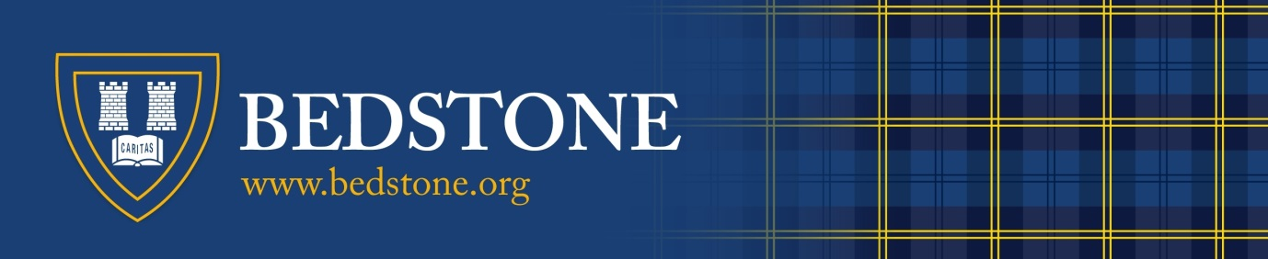

Headmaster's Message
Bedstone College is a leading independent day & boarding school in beautiful countryside near Ludlow; located on the Herefordshire, Shropshire and Powys borders. We are a co-educational, ‘All-Through’ school, serving children from Reception age through to Sixth Form.
You are undoubtedly wondering what it is that sets us apart from the many other schools that you see. The simple answer is: "our young people".

Visitors to Bedstone are immediately struck by the friendly atmosphere of the school; the openness and confidence of our students, the support that they give to each other and the fact that the children are patently enjoying life at school.
Thank you for expressing an interest in working with us. Life at Bedstone is incredibly rewarding and I am sure that you will be excited at the prospect of joining us if you are invited to interview. If you require further information on the post for which you are applying, please do not hesitate to contact us at your convenience.

I wish you all the very best with your application!
David Gajadharsingh
Headmaster
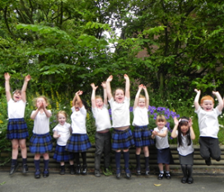
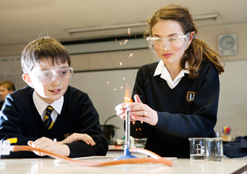
Bedstone College Shropshire SY7 0BG 01547 530961 admissions@bedstone.org
An Independent Boarding & Day School for Boys & Girls Aged 4 - 18

