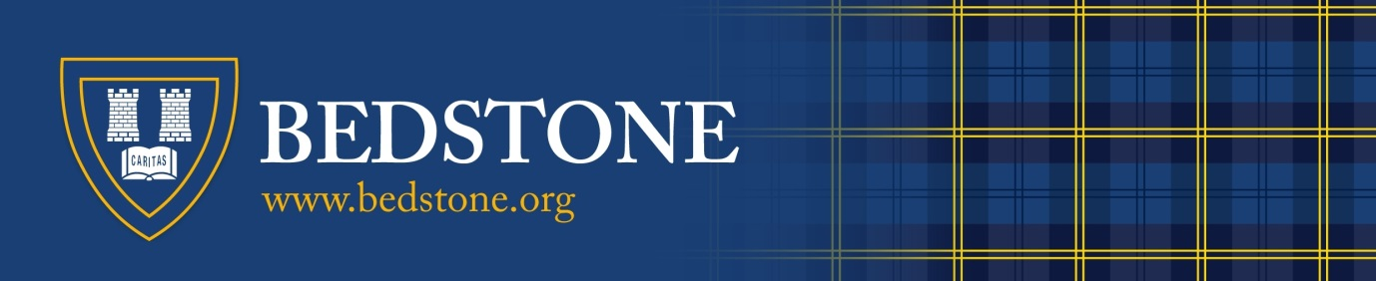

RESULTS DAY SUMMER 2018

AS and A Level: THURSDAY 15TH AUGUST 2019

GCSE: THURSDAY 22nd AUGUST 2019

The following procedures will be in place for results day:-

From 08:00am
Students/Parents may attend the college in person to collect results. Please come to the Reading Room. The results letters are addressed to the students. The results contained within are their property. If you would like someone else to collect the results on your behalf can you please give them a letter, signed by you, (the student), to confirm that this is the case.

From 09:30am
Students/Parents may telephone the college to receive their results. Please call the main college line: 0044-(0)1547 530303. To confirm your identity you will be asked for a password which is: “1948”. If a student wishes for their parent or other person to contact the college by telephone to receive their results, then they should alert the college, (Head’s PA), to this before they leave for the summer holidays by emailing at pa@bedstone.org

Mrs Wendy Martin (Head), Mr John Lynch (Deputy Head Pastoral), Mr Chris Braden (Head of 6th Form + Careers) along with Mr Andrew Whittall (Deputy Head Academic) will be available for advice and of course, if you attend the college in person, you may use school telephones and computers to access university admissions offices (U6th)

All results not collected/given over the telephone will be posted out the following morning.

In addition: All U6th Students will receive a booklet outlining the process of UCAS offers and clearing before they leave the college at the end of this term.

