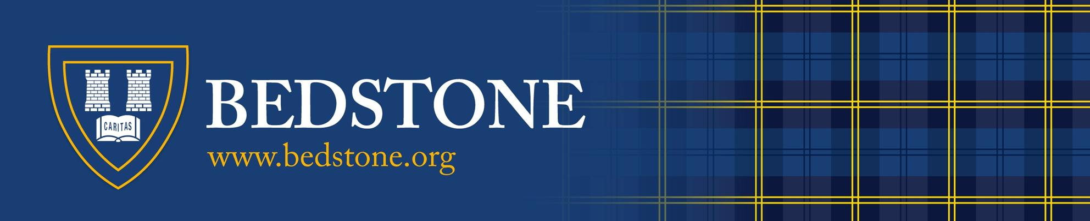

STAFF academic year 2019

The Governing Body:

Chair of Governors: Grp Capt J. Fynes RAF (Retd)

Vice Chair: Mrs Y Thomas BSc

Governors: Professor M Lawton
Mr V Phillips
Mrs S Phillips
Mr S Stringer
Mrs M Hayman

STAFF:

Head: Mrs W Martin BSc (Hons), PGCE
Deputy Headmaster (Pastoral): Mr J Lynch BA, PGCE, MA (Ed)
Deputy Headmaster (Academic) & Head of Boarding: Mr A A Whittall BA, PGCE
Head of Junior School : Mr J Forster BSc, PGCE, MSc
Bursar: Mr A R Gore AFA

HOUSEPARENTS:

Boys: Boarding Girls: Boarding
Pearson House Mr & Mrs A Whittall Bedstone House Mr & Mrs P Singh
Rutter House Mr & Mrs O Downing Wilson House Mr & Mrs M Rozee

MEMBERS OF THE COMMON ROOM :-

CB Mr C Braden BEd, PGDip Man (Head of Design Technology)
EB Mrs E Bryden BA, PGCE, MMus (Head of Music)
LB Miss L Bullock MA PGCE Cert (Head of History & PSHE)
EC Miss E Coyle BSc, PGCE (Teacher of Science/ Psychology + Boarding House Tutor)
JC Mrs J Crouch BA, PGCE (Teacher of DT/Maths and Art + Boarding House Tutor)
OD Mr O Downing BA, PGCE (Head of English + Houseparent)
DMF Dr D Foreman BSc, Phd, PGCE (Head of Biology/Psychology + Boarding House Tutor)
CS Ms C Simmons MA (Oxon) PGCE (Teacher of Mathematics)
CH Mrs C Hunter CDMVA (La Sorbonne) (Head of MFL + Boarding House Tutor)
GK Ms G Kindermann BA, MA (univ.potsdam) (Head of EAL)
JGL Mr J Lowe MA, DipRSA (Dyslexia), PGD (SEN and Inclusion), PGCE, CPT3A, SpLD APC (Patoss) (Head of Learning Support )
DM Mr D P Marsh, BSc, PGCE (Head of Geography + Boarding House Tutor)
NN Ms N Newman MA, PGCE (Teacher of English + Boarding House Tutor)
CN Mrs Catherine Newnham, BSc, PGCE (Teacher of Biology)
SM Mrs S Morris BA, PGCE (Head of RE)
EO Mr E Olive , BSc, PGCE (Head of Physics + Boarding House Tutor)
DMR Dr D M Rawlinson BSc, PhD, PGCE (Head of Mathematics)
MR Mr D M Rozée BSc, PGCE, MRSC (Head of Science/Chemistry)
SR Miss S Ross, BA, QTS (Head of Girls’ PE + Games + Boarding House Tutor)
JRS Mr J R Simpson BA, QTS (Head of Boys’ PE + Boarding House Tutor)
JS Mr J P Smith BA (Head of Art + Boarding House Tutor)
MW Mr M Watson BA (Teacher of MFL + Boarding House Tutor)
NW Mrs N Williams BSc (Econ), PGCE (Head of Business Studies)

Junior School: Head of Deparrtment: Mr J Forster BSc, PGCE, MSc Mrs J Richards BA,PGCE, MA (Ed)
Mrs S Crabtree BA
Mrs J Williams
Mrs E Hood BA, PCGE
Mrs L Meredith NNEB
Mrs R Rawlinson BSc, MSc, PGCE

Learning Support: Head of Department: Mr J G Lowe, MA, DipRSA (Dyslexia), PGD (SEN and Inclusion), PGCE, CPT3A, SpLD APC (Patoss)
Miss S Armitage-Pryce , BA, PGCE

EAL: Head of Department: Ms G Kindermann BA, MA (univ.potsdam)
Mr C Morris

Lay Chaplain: Mr A C Dyball MA (Cantab), Dip.Ed

School Sisters: Mrs N Stead RGN and Mrs R Revuelto-Barrett

School Doctors: Dr M L Kiff & Dr A Lempert

Visiting Music Staff: Mr D Kirk (Drums) Mr J Hymas (Violin)
Mr D Luke (Guitar) Mrs K Norton (Piano)
Mrs S Freeman (Brass) Ms S Lee (Singing)
Mr J Nicholls (Piano) Mr C Lacey (Woodwind)

Competitive Houses Stokesay Miss S Ross
& Housemasters Hopton Miss Lucy Bullock
Wigmore Mr J Lowe

Headmaster’s PA: College Receptionists:
Ms Paula Davis Mrs Wendy McKee-Wills
Miss Jessica Naprous

Accounts Administrator: Accounts Clerk:
Mr Paul Downes Mrs Sara Gore BSc

Head of Admissions, Marketing & Enterprise: Marketing + Communications Officer
Mr Graeme Neill Mrs Roz Pacey

Assistant to Head of Admissions Marketing & Enterprise: Transport Manager:
Mrs Anne Whittall Mr Parvinder Singh

IT Manager: Maintenance Manager:
Mr Steven Davis Mr Stuart Pullen

Science Technician : Catering Manager:
Mrs Julie Rozee Mrs Meradtih Hart

Domestic Supervisor:
Mrs Debbie Gough

