Junior School

Curriculum Overview

EYFS/Reception/KS1 – (Junior 1)

2022/2023

Rec/KS1 | Autumn | Spring | Summer
Art & Design | Colour Chaos | Joan Miro | Nature Sculptures
Computing | Computer Skills | Using the Internet | Programming
Geography | Our Local Area | What a wonderful World | Our School
History | Farms/  War and Remembrance | Space/  Mythical Creatures | Around the World in 80 days!
Religious Education | Belonging (Y0/Y1)  Rules and Routines (Y2)  Christmas (All) | Nature and God/  Easter | Beginnings and endings/  Places of Worship
Science | Living things and their habitats  Animals including humans | Use of Everyday Materials  Seasonal changes spring and summer | Plants  The Environment
PSHE | Families and Friendships  Safe Relationships  Respecting ourselves and others | Belonging to a community  Media Literacy and digital resilience  Money and Work | Physical Health and Mental Wellbeing  Growing and Changing  Keeping Safe

** Music – Mr Fletcher
** PE – Miss Beddow and Mr Jones

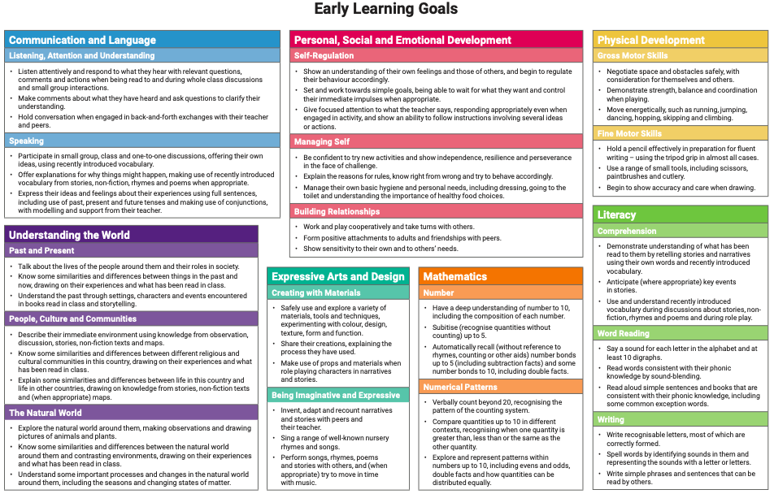

Maths

 | Autumn | Spring | Summer
EYFS | Number  Shapes and Patterns  How Many?  Time  Comparison and Measure | Number  Position and Time  Addition and Subtraction  Comparisons and Measure  Shape  Money | Number  Comparing and Measuring  Addition and Subtraction  Shapes and Sorting  Clever counting  Time  Patterns
Y1  Y2 | Place Value  Addition and Subtraction  Measures  Time | Fractions and Multiplication  Place Value  Addition and Subtraction  Money and Time  Measures and Data  Multiplication | Place Value and Fractions  Addition and Subtraction  Multiplication and Division  Fraction and Time  Shape

Literacy

 | Autumn | Spring | Summer
Writing | Fiction -Traditional Tales  Feelings  Non Fiction -Persuasion/Letter Writing  Poetry | Fiction – Character Description/Adventure Story  Non-Fiction - Information texts/Recount  Poetry | Fiction – Story from another culture/Retelling a story with changes  Non-Fiction -Instructions/Poster  Poetry
Grammar | Different types of sentences  Co-ordinating and subordinating conjunctions  Adjectives  Expanded noun phrases  Prepositional Phrases  Basic punctuation | Co-ordinating and subordinating conjunctions  Adjectives  Expanded noun phrases  Prepositional Phrases  Suffixes and Prefixes  Tenses  Basic punctuation  Paragraphs (Y2)  Speech (Y2) | Tenses  Paragraphs  Basic Punctuation  Expanded Noun Phrases  Prefixes and Suffixes

